Purpose: Purpose of this documentation is to import Business Units and Teams records with **same GUID** to be maintained.

Import the Data Maps (Business Unit Data Map.xml, Teams Data Map.xml) provided into the target CE instance before Data import.

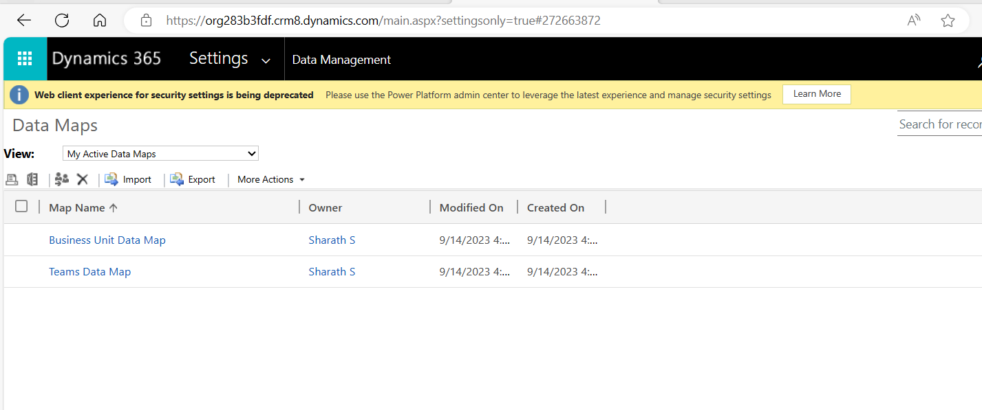

In BU excel provided update the parent business unit column of below highlighted record to Root BU of target instance

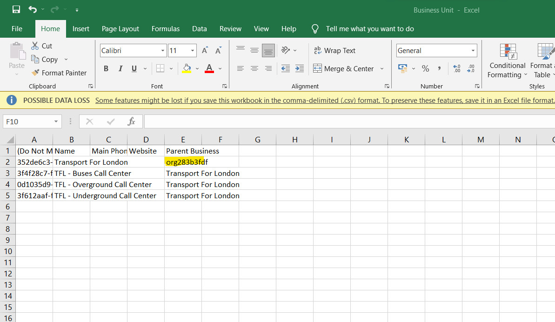

Go to Target CE environment Data Management -> Imports -> Click on Import Data button

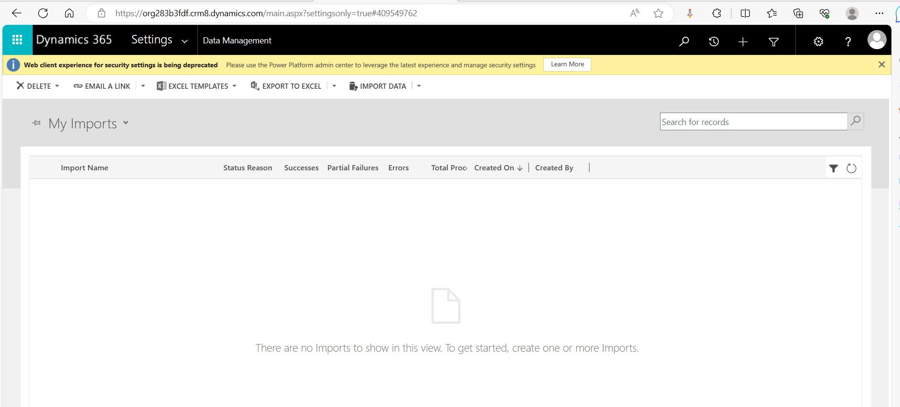

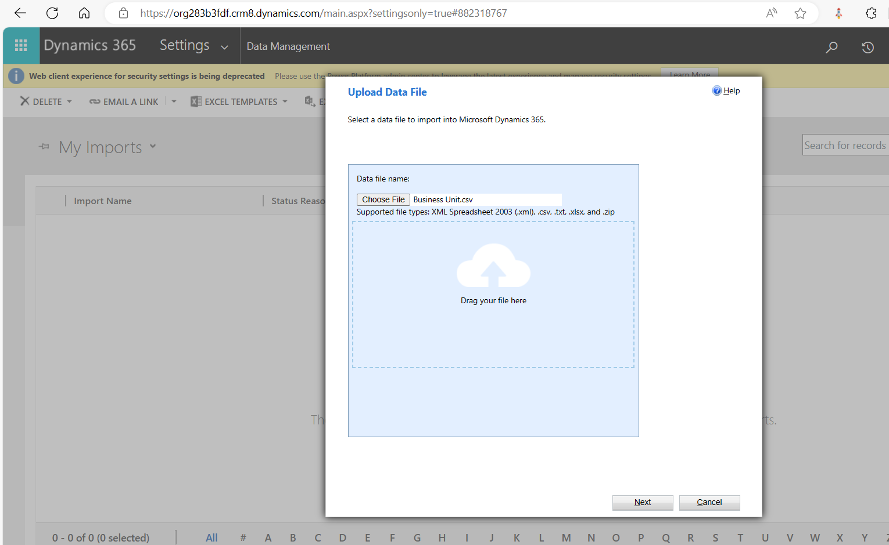

Click Next

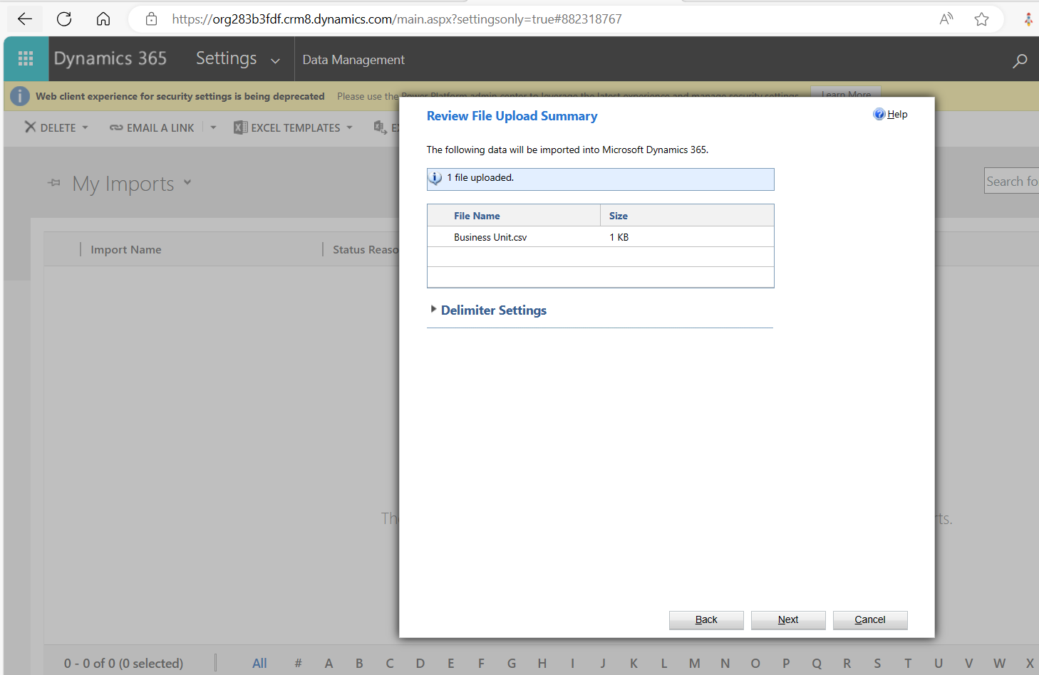

Click Next

Select the data map as mentioned in below screenshot and click next

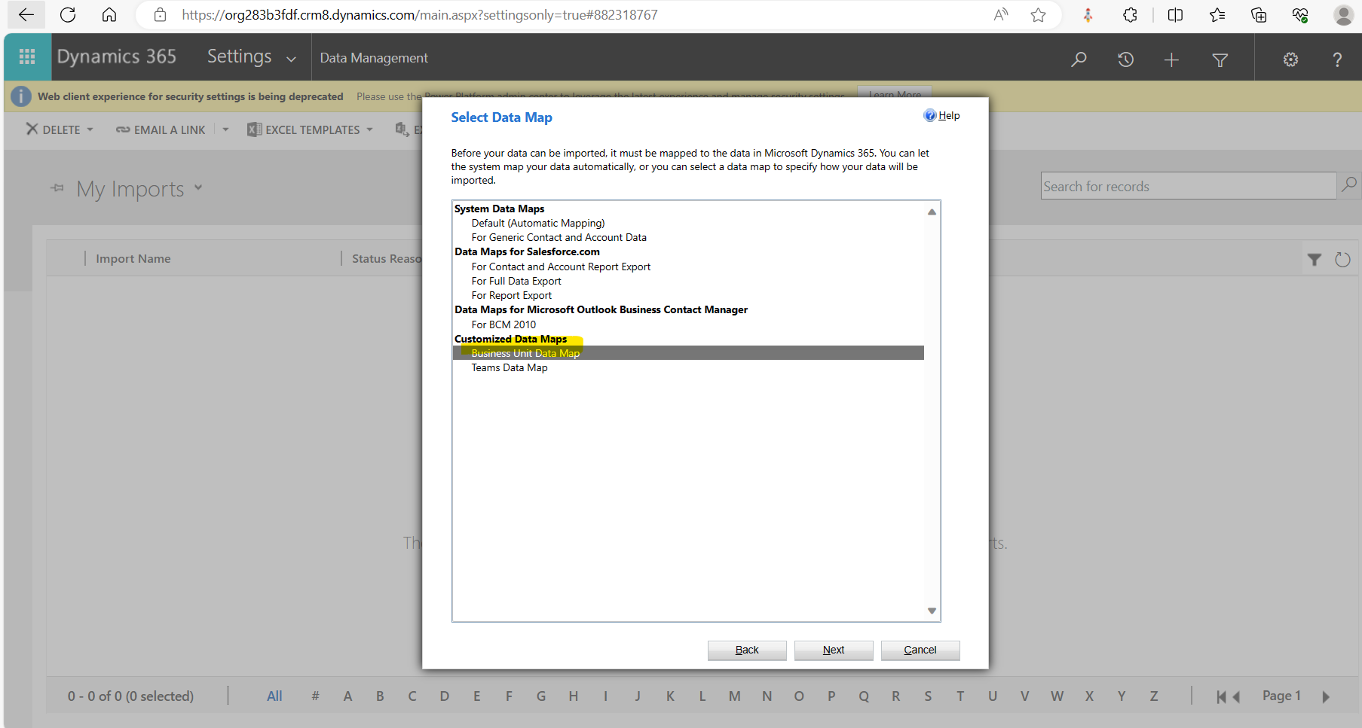

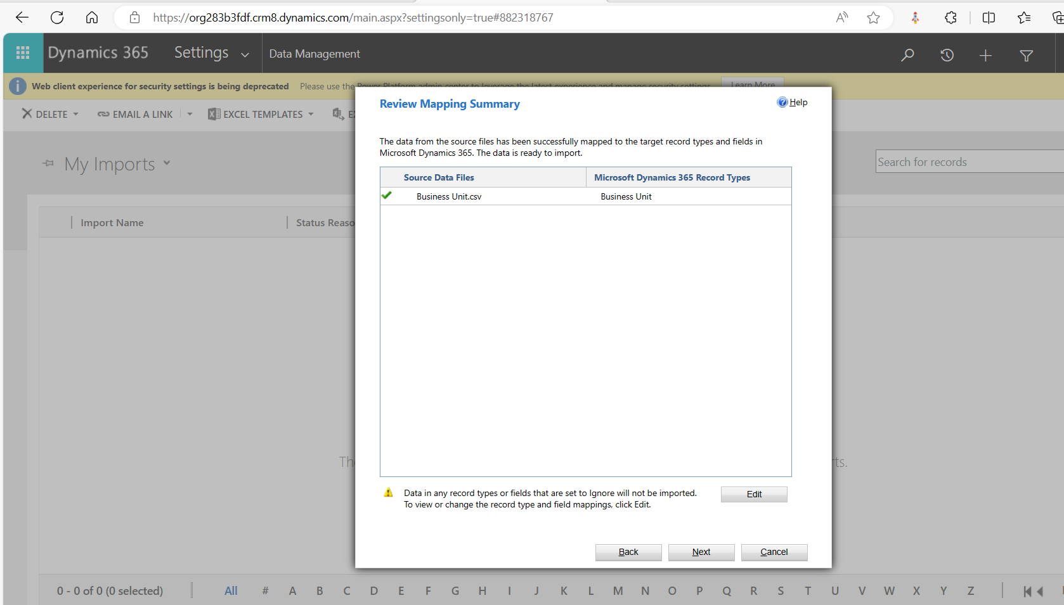

Click next

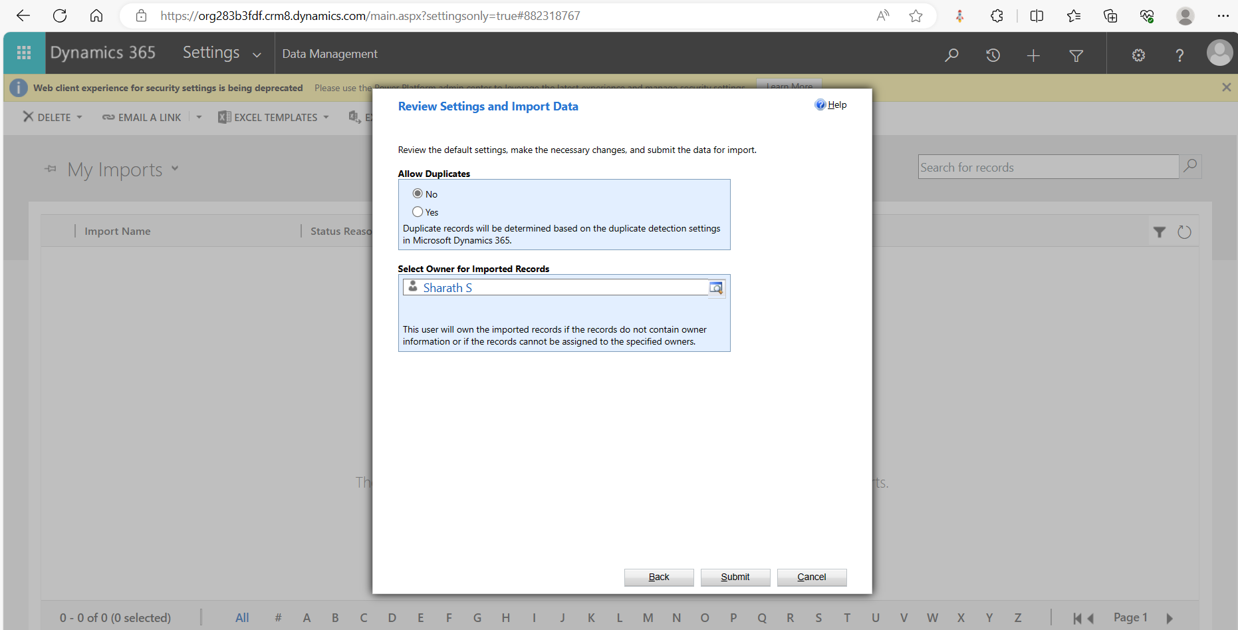

Click Submit and then in next pop-up click Finish , data will be imported to CE.

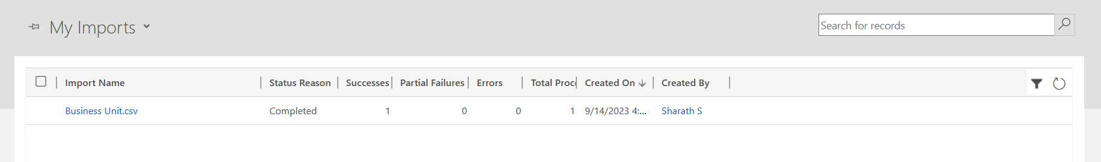

Follow the same above process for Teams csv import (select the teams related csv map) as per below screenshot

